## Introduction:

The interfaces I have chosen are the 2 online book purchasing websites, "Whitcoulls" ( <https://www.whitcoulls.co.nz/> ) and "MightyApe" ( <https://www.mightyape.co.nz> ). The task my helper carried out was to search for, find and then purchase a book called " A wanted man" by Lee Child's (the paperback version). My prediction is that I am expecting that Mightyape will be the better website to use as I have used it before and found it better to use. I faced challenges with Whitcoulls because the layout bored me so I wasn’t really into it and the book was more expensive even though that has nothing to do with the website itself the book was still more expensive making me think that MightyApe is the better website. The website felt like it needed more to attract more people as they used boring font and colors for their interface. I do think that MightyApe has more of a range of items and these items are easy to access through the website. Whitcoulls on the other hand is harder to find an item you want making the customer irritated.

Both the above interfaces are used to purchase books and other items online. The kind of steps I would expect would be to:

1. Use Google to locate the websites,
2. Use the various websites search functions to find and identify the required version of the book,
3. Use a secure order and purchase function in order to buy the book,
4. Have it sent to our home by a safe and secure manner,
5. Achieve all this as cheaply as possible.

Some Negative and Positive characteristics of the Whitcoulls website were:

Positive

-The book was easier to purchase as it had a guest only function, requiring no registration or login.

-The website had a store locator making it if you need to go into the store it is easier to find.

-The delivery day for the purchased item was sooner.

Negative

-The book was hard to find because the search function returned with too many options making the book hard to find for my helper.

-The website layout and coloring was boring and bland over all it wasn’t inviting.

Some Negative and positive characteristics of the MightyApe website were:

Postive

-The book price was cheaper whereas as the Whitcoulls one was quite expensive.

-Greater security due to registration requirement.

-The search function was a lot better than Whitcoulls.

Negative

-The website layout seemed cluttered and busy making my helper a tad annoyed.

-The website required registration and a login to order and purchase as there was no guest function.

Whitcoulls first impression was colorful but functional. Had a standard search bar, comes up with all titles of books related to the search. Whitcoulls seems to be a sufficient website. The book that is being purchased is 'A wanted man' by Lee child's. There is a good description of the book and what it's about. The books costs $25.99 which is a tad on the expensive side. It gives the option to see if its available in any stores near you. Very easy to buy the book as there is no Requirement to register in order to buy the book. The security for purchasing the book is adequate even though the process is quite slow and has a very expensive delivery cost which is $3.90 and the layout is quite bland with white backgrounds and standed text but overall Whitcoulls is a functional website.

MightyApes first impression was Busy and also colorful with a far wider selection than whitcoulls. The search bar is better placed and looks better. The book is also cheaper but with the same delivery cost as whitcoulls. The search for the book also had similar results. But the details of the book description were better and even included an author biography. Also had secondary purchase options and just as easy to purchase but registration is required which irritated my helper, the registered customers have better purchase security but overall the website is good and easy to use.

Pictures of the Websites down below.

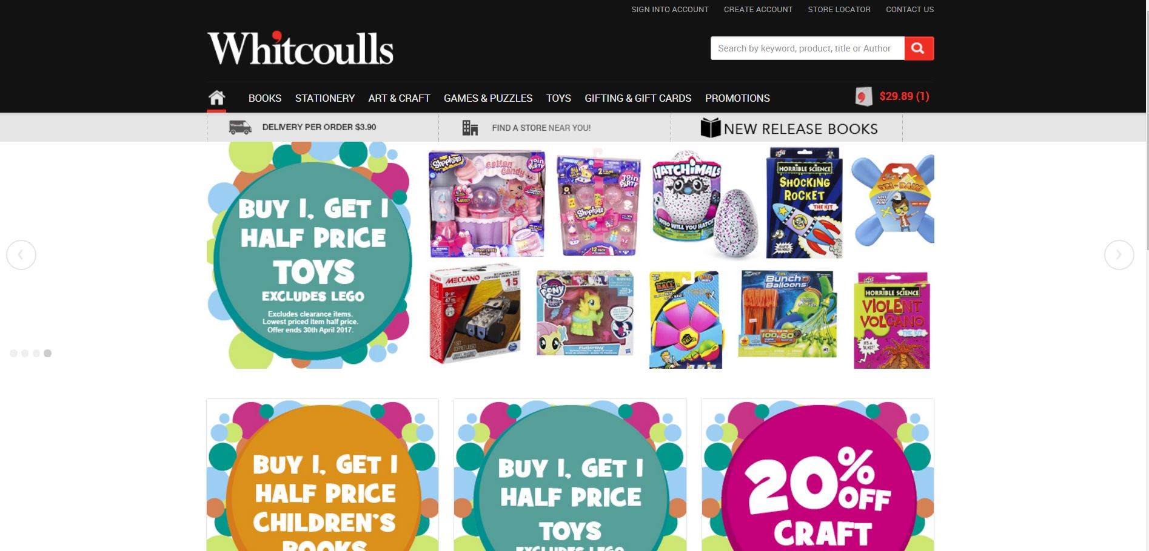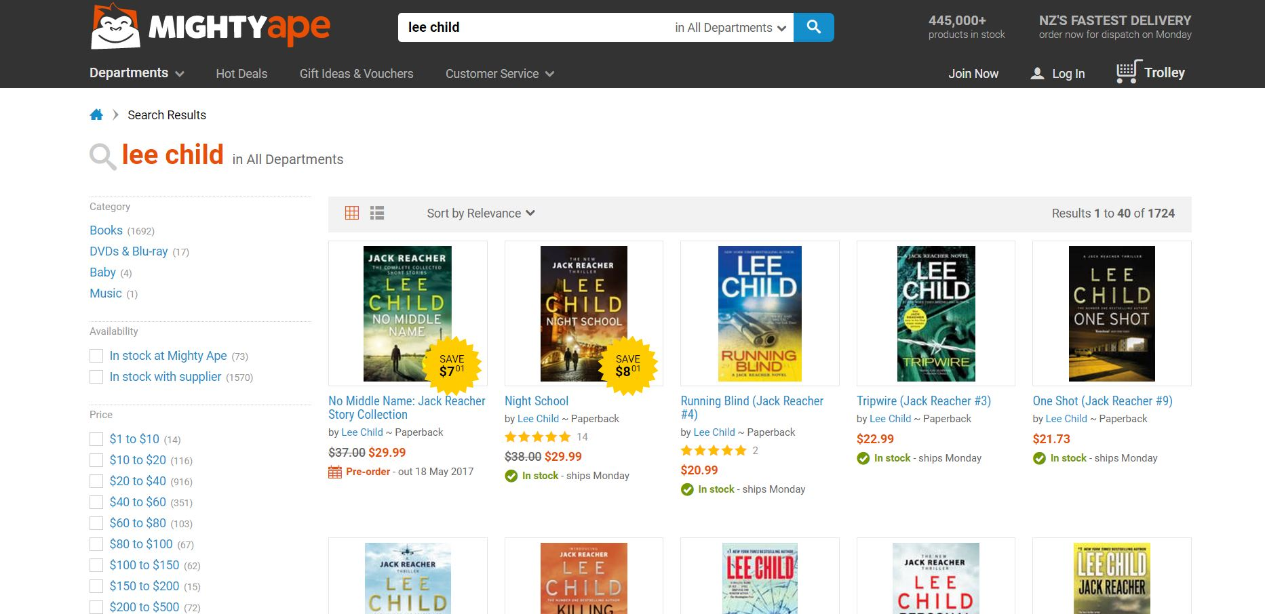

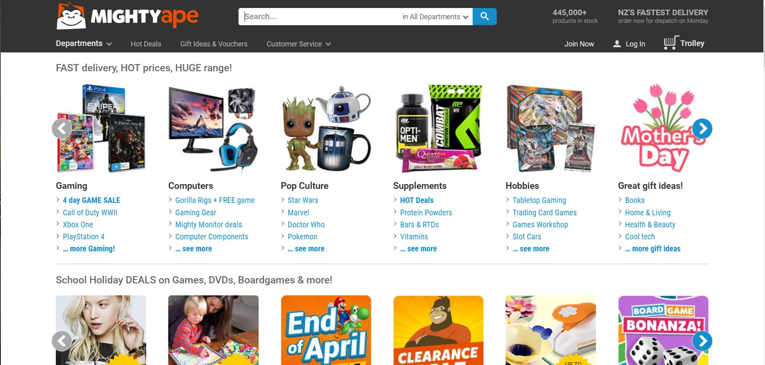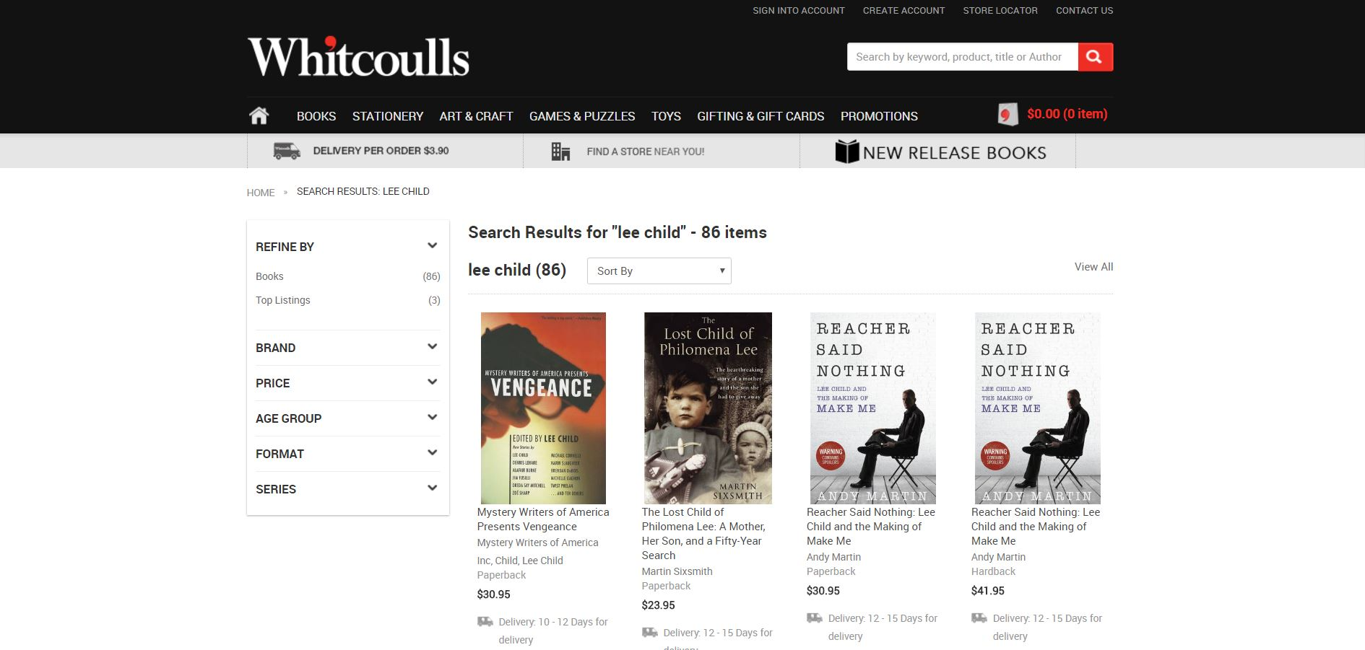

These images on the left show the website homepages. As you can see mightyapes homepage is quite busy and overdone where's as whitcoulls is plain and a tad boring. On the right hand side is my helper looking up the book he is trying to purchase, MightyApe came up straight away with all of lee child's books which was annoying for my helper as he had to go through all of them to find the one he wanted. The Whitcoulls on the other hand came up straight away with the book he wanted so he didn’t have to go through each one, he was happy with this.

Conclusion:

Both websites both had good and bad characteristics on them but the book my helper was looking at purchasing was brought through the mightyape interface as he found the book cheaper and the website was easier to use even though the book takes longer to arrive (9 days instead of 5). My helper does prefer mightyape over whitcoulls as it has a wider selection and a more modern interface. The bright colors both websites used were good because it made my helper feel invited and it looked interesting. An idea to stay away from would be not to bombard the user with too many options at once so the home page isn't busy or look cluttered.